PROJECT TITLE

College Name: Sri Ramakrishna college of arts and science for women.

College Code:Bru28

TEAM ID: NM2025TMID24115

TEAM MEMBERS:

Team LeaderName**:** Varshini.K.R

Email: srcw2326j152@srcw.ac.in

Team Member1: Hemalatha.R

Email: srcw2326j120@srcw.ac.in

Team Member: Janani.B

Email: srcw2326j122@srcw.ac.in

Team Member: Karuthika.T.R

Email: srcw2326j126@srcw.ac.in

**1.INTRODUCTION**

**1.1 Project Overview**

This project aims to reduce food wastage and alleviate hunger by collecting surplus or leftover food from households, restaurants, hotels, canteens, and events, and redistributing it to underprivileged communities. Every day, large amounts of edible food are discarded, while millions of people struggle with hunger. This initiative bridges that gap by creating a structured system for safe collection, storage, and distribution of excess food.

**1.2 Purpose**

The purpose of this project is to reduce food wastage and fight hunger by channeling surplus and leftover food from households, restaurants, hotels, and events to people in need. Every day, large quantities of edible food are thrown away, while many underprivileged individuals go hungry.

**DEVELOPMENT PHASE**

**Creating Developer Account:**

By using this URL - <https://naanmudhalvan.smartinternz.com/>

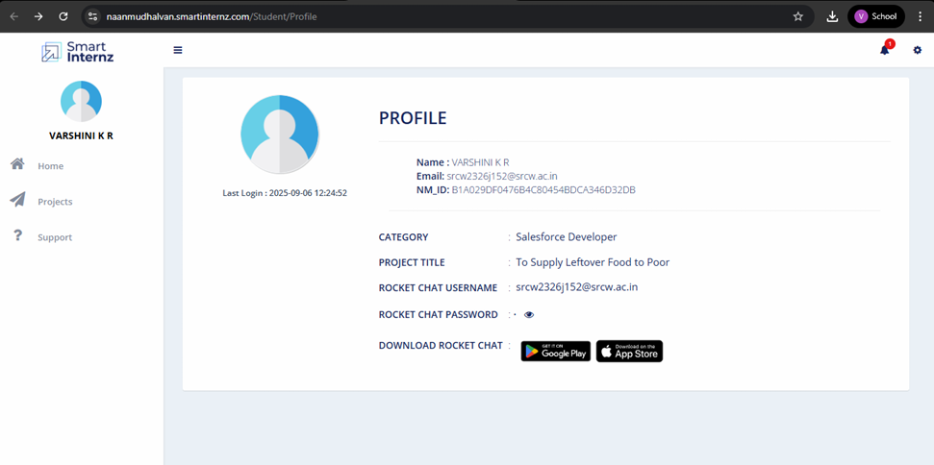

**Salesforce developer account creation**

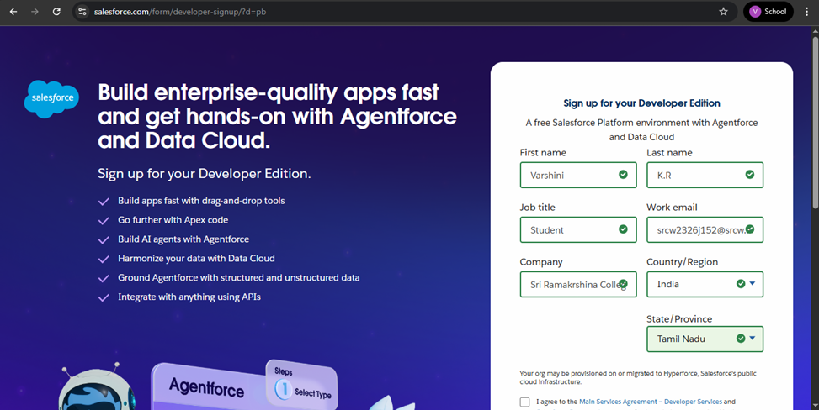

**Account Activation**

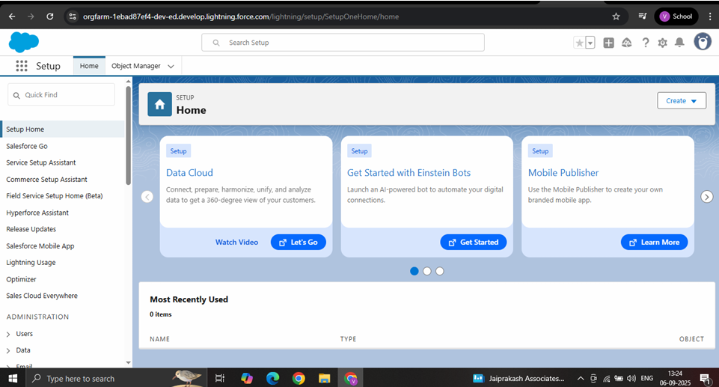

**Object**

**Create :** Venue,Drop-Off Point, Task, Volunteer, Execution Details Objects

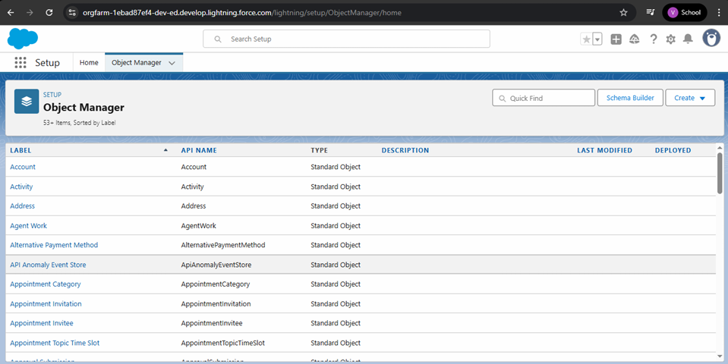

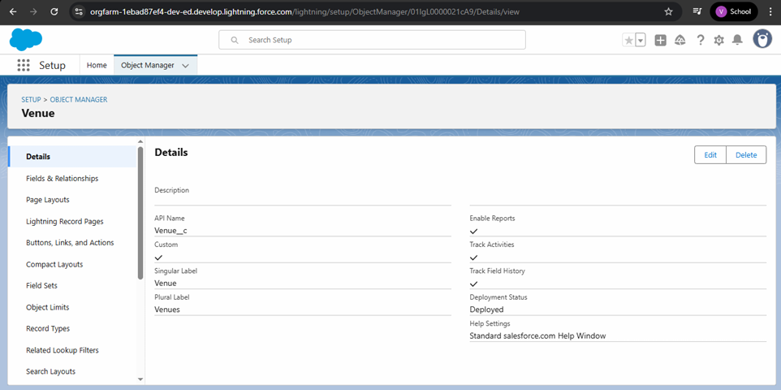

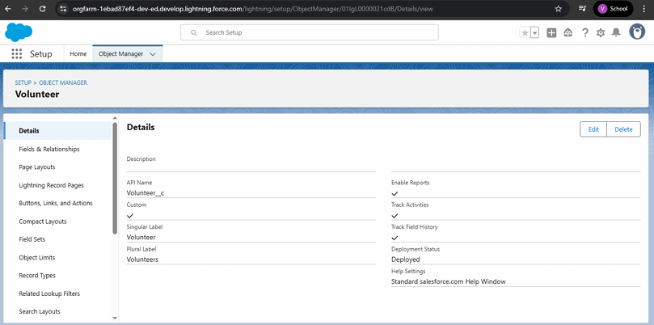

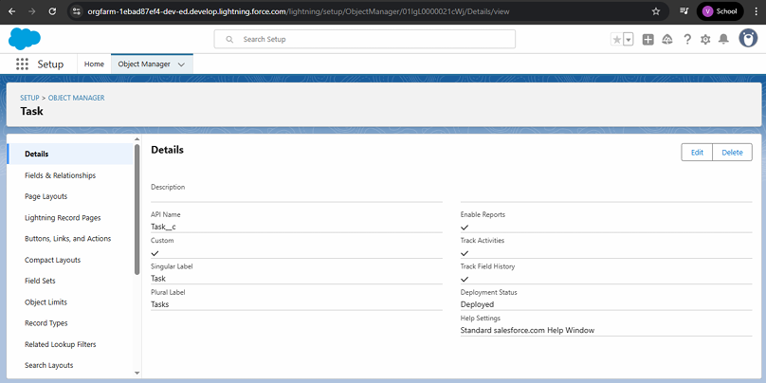

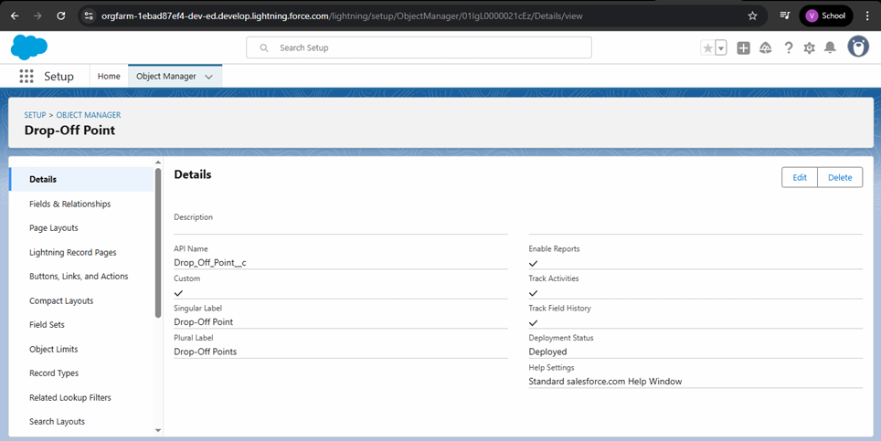

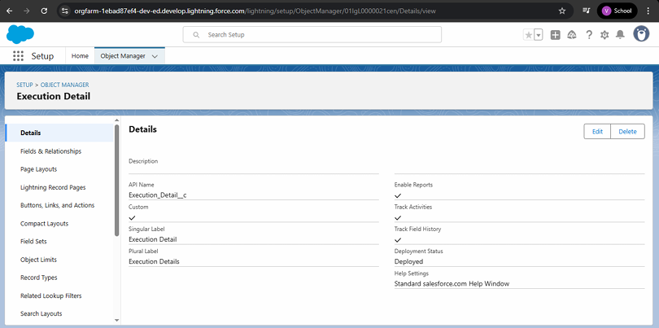

**Creating a Custom Tab**

Venue,Drop-Off Point, Task, Volunteer, Execution Details Tabs

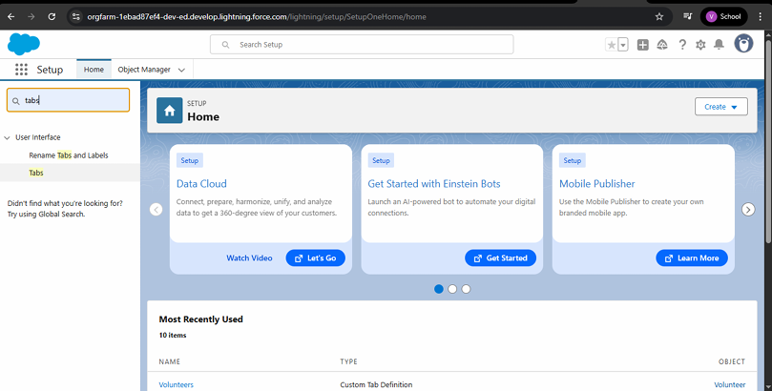

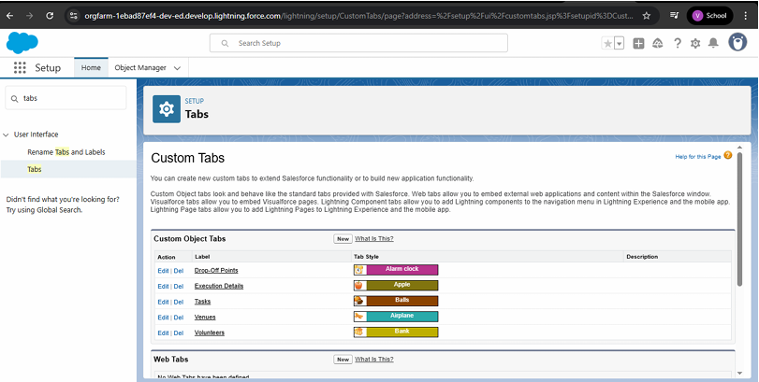

**Create a Lightning App**

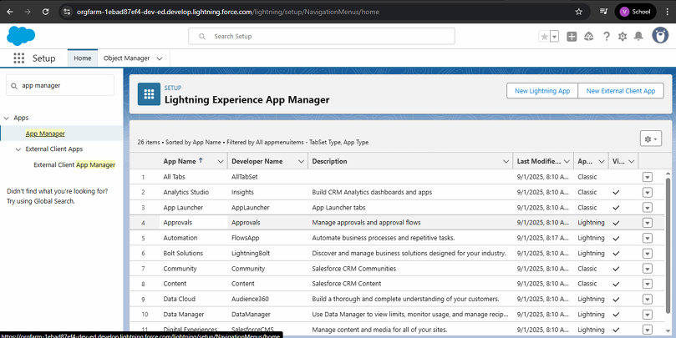

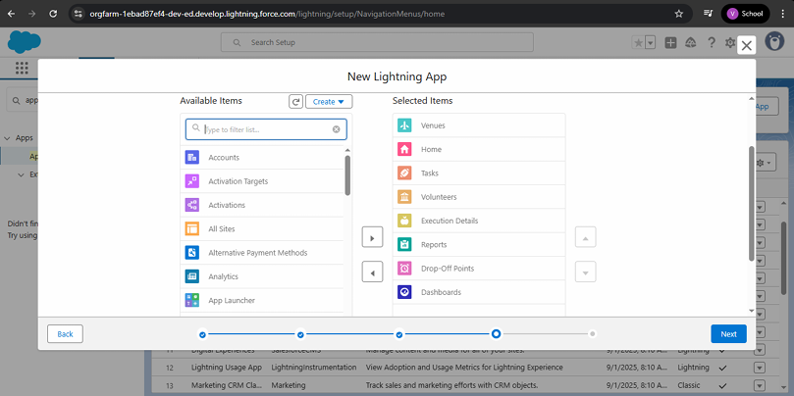

**Fields**

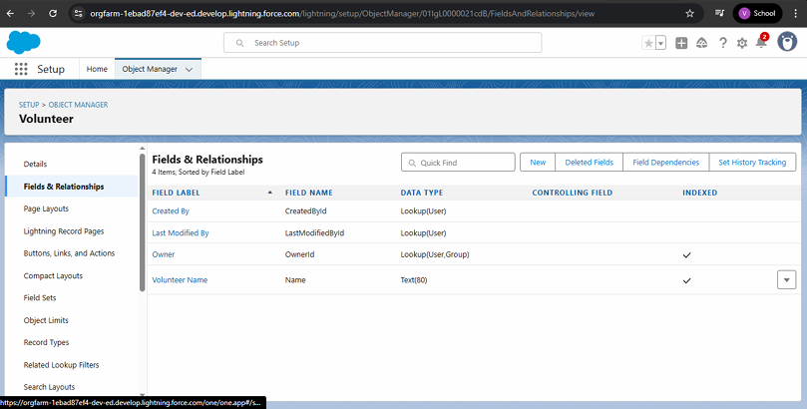

**Creation of Relationship fields in objects**

Creation of Lookup Relationship Field on Volunteer Object

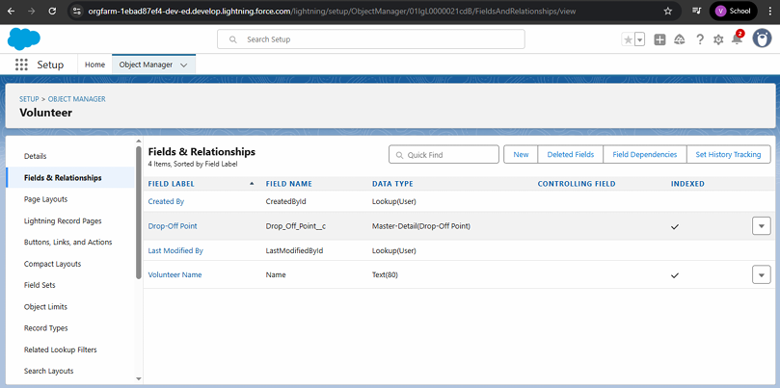

Creation of Master Detail Relationship Field on Execution Details Object

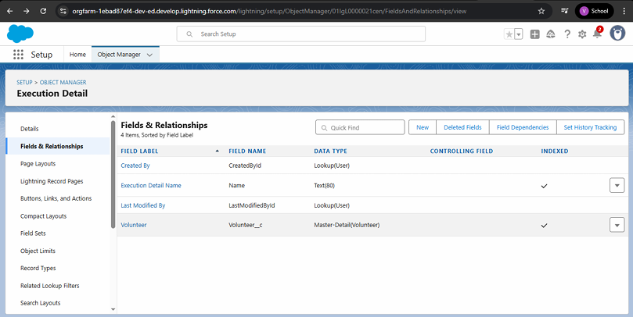

Creation of Master Detail Relationship Field on Execution Details Object

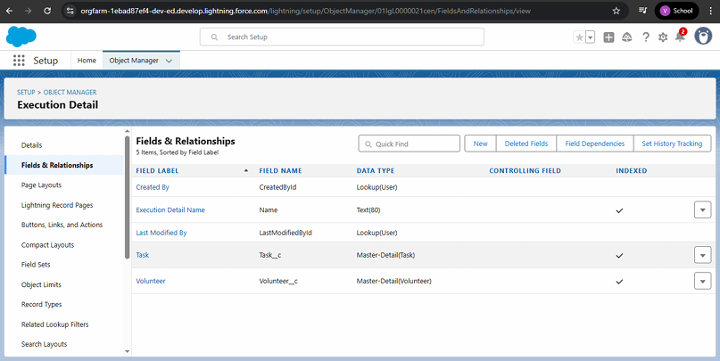

Creation of Lookup Relationship Field on Drop-Off Point Object

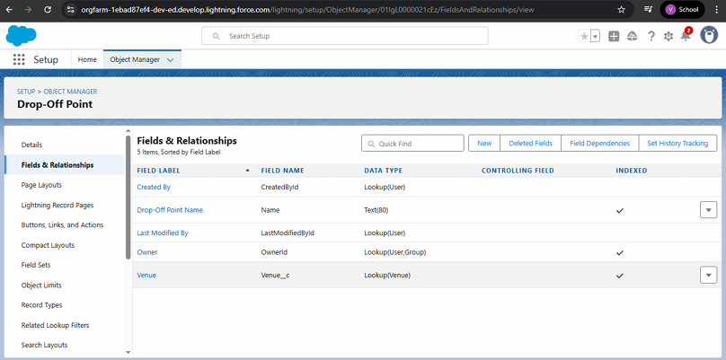

Creation of Lookup Relationship Field on Task Object

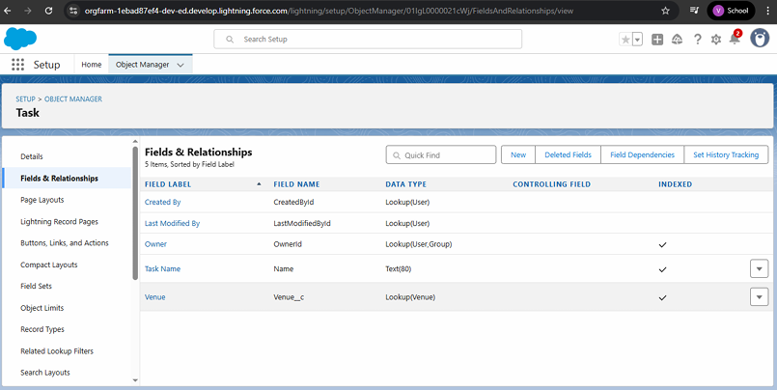

Creation of Lookup Relationship Field on Task Object

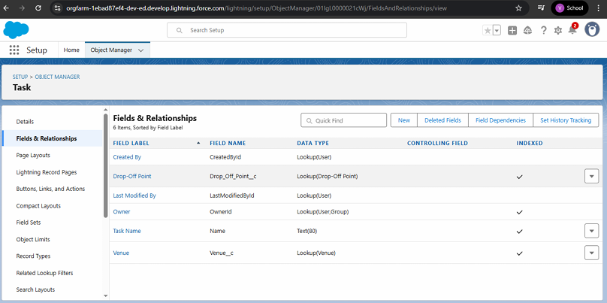

Creation of fields for the Venue object

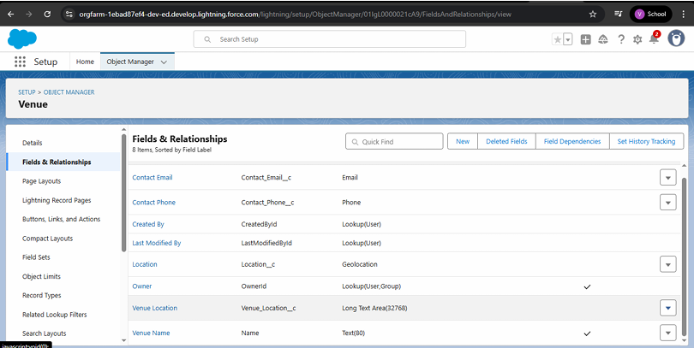

Creation of fields for the Drop-Off point object

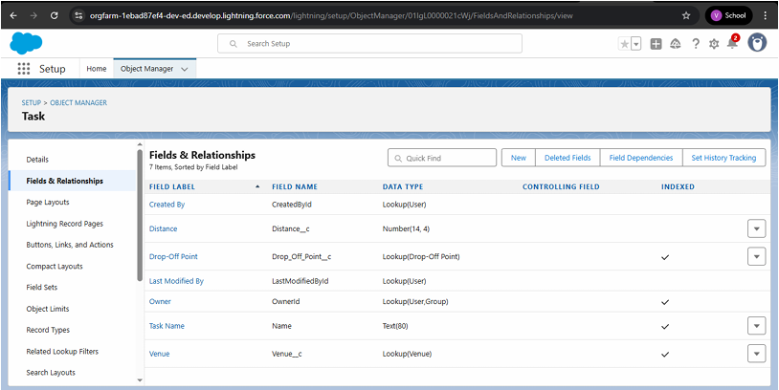

Creation of fields for the Task object

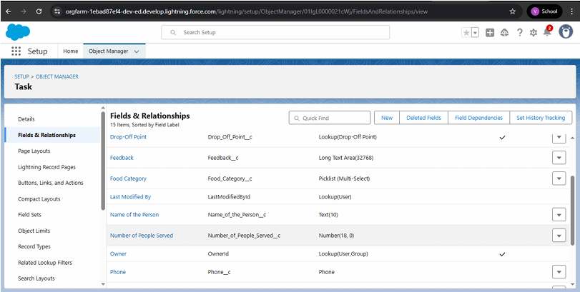

Creation of fields for the Volunteer object

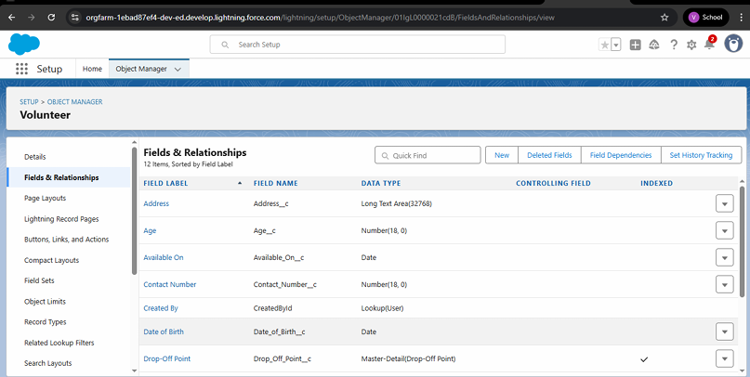

Creation of fields for the Execution Details object

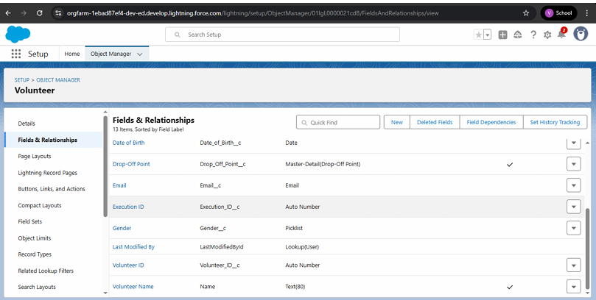

**FLOWS**

Create Flow to create a record in Venue object

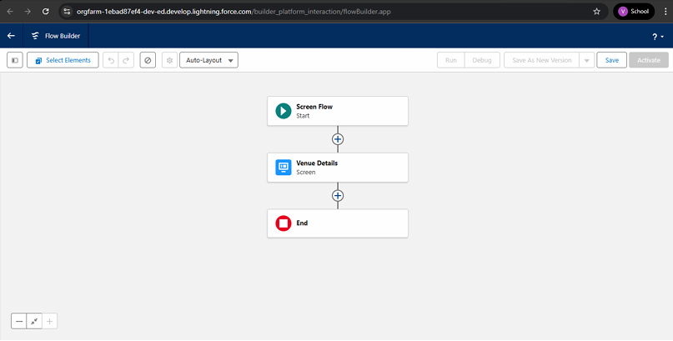

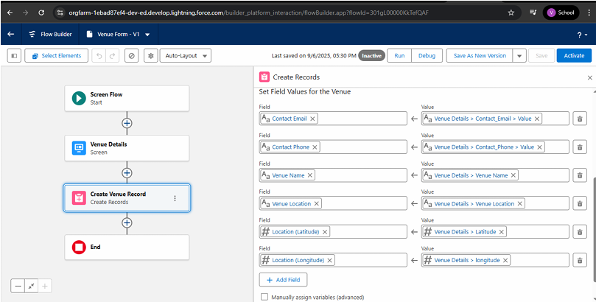

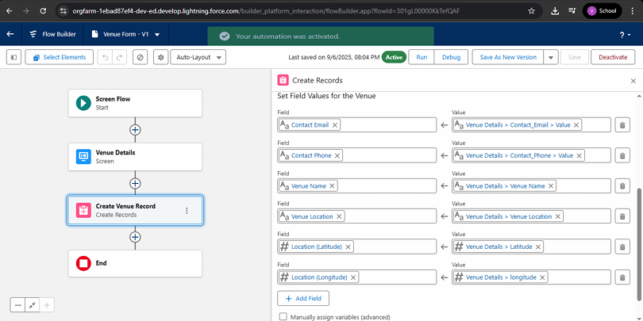

**Trigger**

Create a Trigger

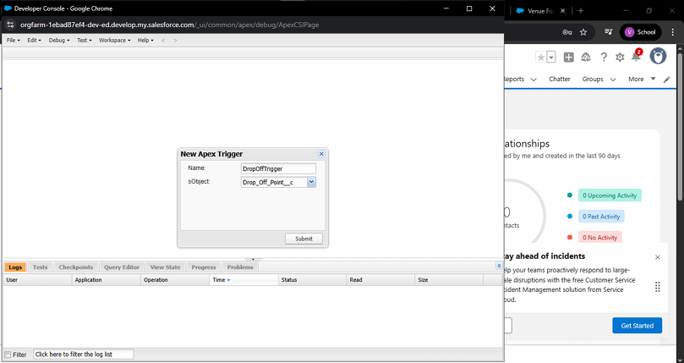

**Profiles**

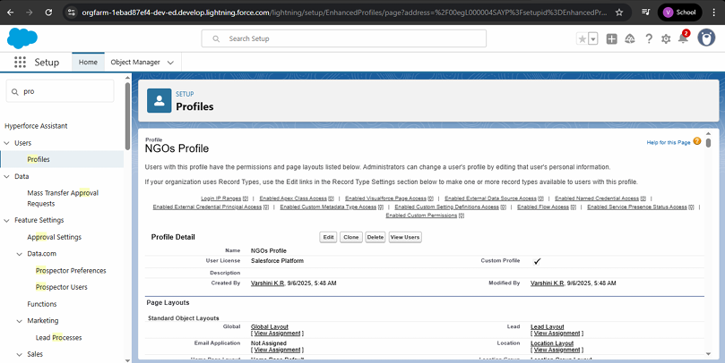

**Creation of Users**

Creation of user 1:

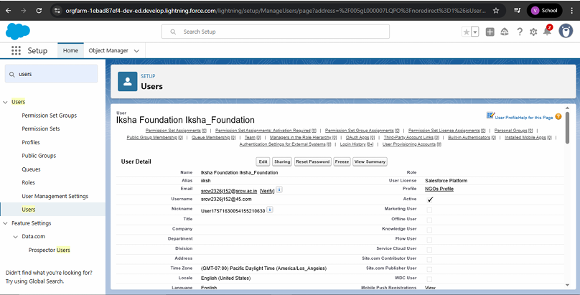

Creation of User 2,3

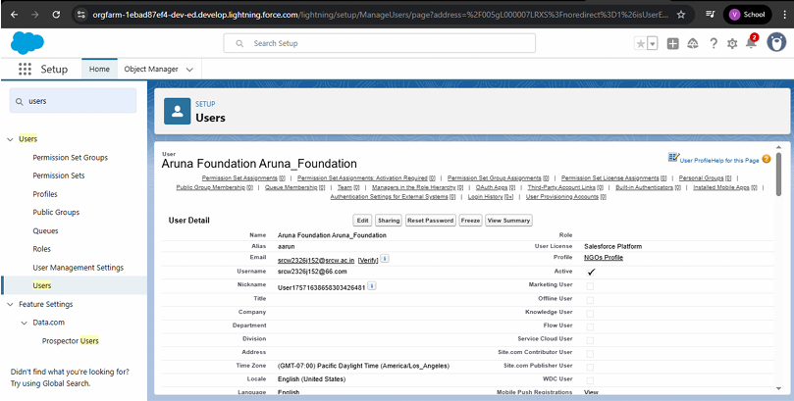

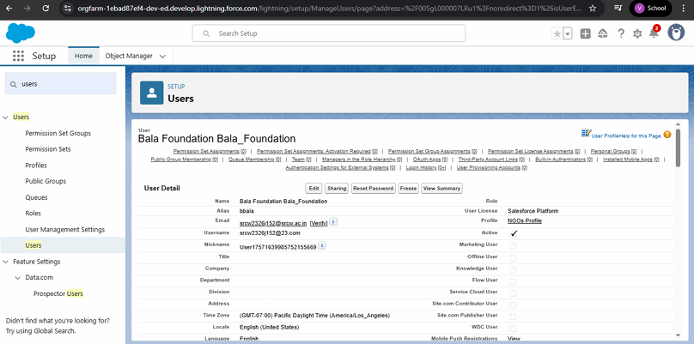

**Public Groups**

Creation of public group 1

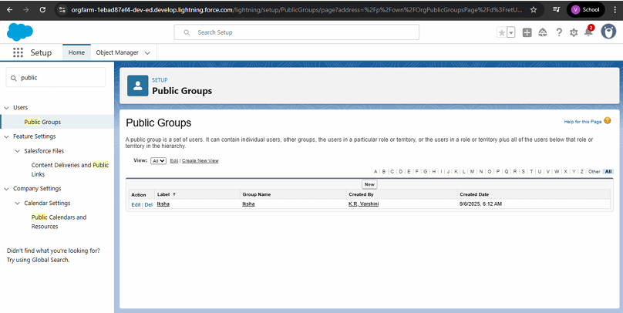

Creation of public group 2

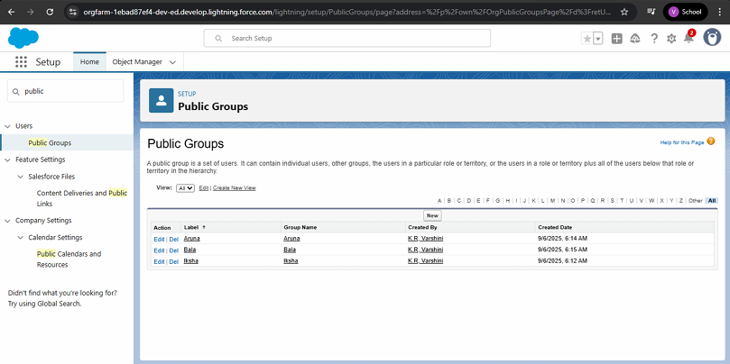

**Report Types**

Creation of Report Types

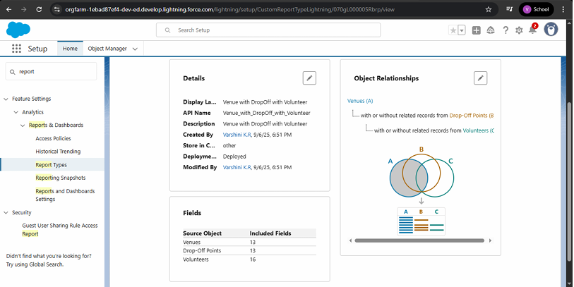

**Reports**

Creation of Report on Venue with DropOff with Volunteer

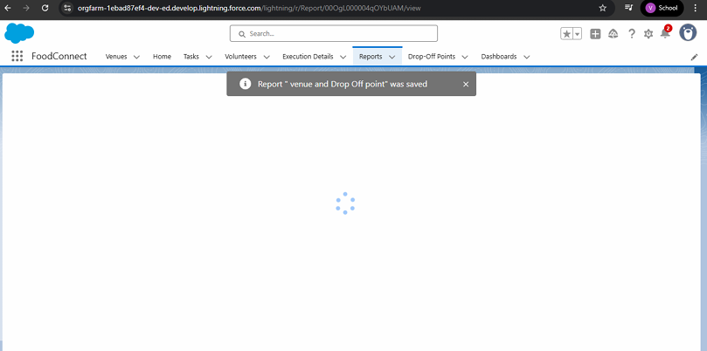

Creation of Report on Volunteers with Execution Details and Tasks

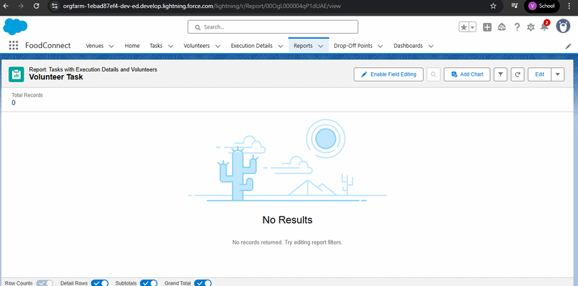

**Dashboards**

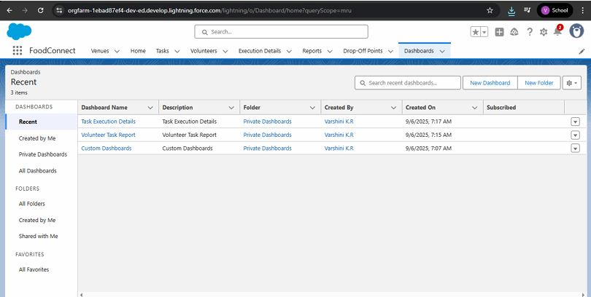

**Sharing Rules**

Creation of sharing rule

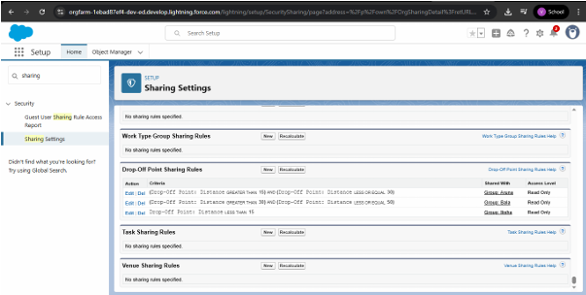

**Home Page**

Creation of Home Page

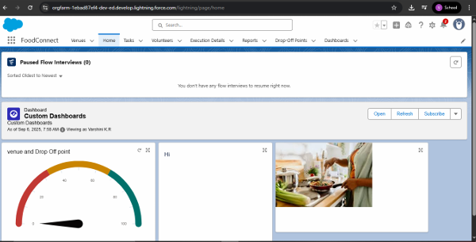

**ADVANTAGES & DISADVANTAGES**

**ADVANTAGES :**

* **Reduces Hunger**: Provides nutritious meals to poor and homeless people who may not otherwise have access to food.
* **Minimizes Food Wastage:** Prevents large amounts of edible food from being discarded.
* **Encourages Social Responsibility:** Builds compassion and responsibility among individuals, restaurants, and communities.
* **Cost-Effective Aid:** Helps the needy without requiring large financial investments, since food is already available.
* **Environmental Benefits**: Reduces the amount of food waste that ends up in landfills, lowering pollution and greenhouse gas emissions.

**DISADVANTAGES :**

* **Food Safety Concerns:** Leftover food may spoil quickly or cause health risks if not handled properly.
* **Logistics & Transportation Issues:** Collecting, storing, and delivering food on time requires proper infrastructure and planning.
* **Limited Food Variety**: The poor may not always receive balanced meals, as leftovers may not meet nutritional needs.
* **Dependency Risk:** Continuous free food supply may reduce motivation for some beneficiaries to seek long-term solutions.
* **Legal & Liability Issues**: Donors may fear being held responsible if someone falls sick after consuming leftover food.

**CONCLUSION**

The project of supplying leftover food to the poor tackles both hunger and food wastage by redistributing surplus food to those in need. With proper planning and collaboration, challenges like food safety and logistics can be managed. Ultimately, this initiative fosters compassion, reduces waste, and promotes sustainable living.

**APPENDIX**

**Source Code**: Provided in Apex Classes and Triggers

**Trigger Code**

**Code:**

trigger DropOffTrigger on Drop_Off_point__c (before insert) {

for(Drop_Off_point__c Drop : Trigger.new){

Drop.Distance__c = Drop.distance_calculation__c;

}

}